Bubwith Bridge

Bridge Design & Assessment, Investigation & Inspection, CDM Principal Designer, Quantity Surveying, Supervision & Technical Advice, Environmental Permits

**Client:**East Riding of Yorkshire Council

**Project Dates:**2022 - 2023

**Project Value:**£800,000

**Contractor:**

Esh Construction

[View more projects and images](https://www.masonclark.co.uk/services-category/bridge-engineering)

**Overview:**

Bubwith Bridge built in 1798 is an 85m long Grade II listed structure over the River Derwent.

The Bridge was badly damaged in a road accident in September 2022, uncovering underlying weaknesses in its structure.

East Riding of Yorkshire Council (ERYC) had to carry out emergency work to ensure the Bridge was safe and structurally sound for its future.

Mason Clark Associates (MCA) provided engineering services to design a scheme to repair the vehicle impact damage to the Bridge, the scheme also included strengthening works and undertaking maintenance repairs to other elements of the Bridge, a vehicle restraint systems was also installed to prevent future damage to its masonry parapets.

# Challenges and Solutions

# The repair and refurbishment works required careful planning and execution to overcome a number of challenges:

# Road Closure: The Bridge had to be closed for several weeks with a 35 mile diversion route in place, affecting the public and local businesses. Regular meetings between MCA, ERYC and Esh were held to discuss any technical queries and issues encountered on-site, these were addressed collaboratively to allow a quick resolution and minimise the duration of the road closure.

# Environmental Considerations: Due to the location of the Bridge an Environmental Risk Assessment was undertaken to raise awareness and to minimise the repair works from causing detrimental effects to nearby wildlife and from contaminating the watercourse, river and surrounding banks.

# Listed Status: Due to the age and listed status of the Bridge, the repairs carried out had to be sympathetic to the existing structure and its surroundings, requiring the use of a specialist workforce and materials. MCA liaised regularly with ERYC’s conservation officer regarding works to the Grade II listed structure.

COMPANY LOGO

# Results

This single-track road bridge underwent a major repair and strengthening scheme, which unavoidably closed the bridge for what was originally planned to last 15 weeks.

But due to the collaborative approach and successful engineering, Esh were able to complete the work in 13 weeks allowing the road to be reopened earlier than planned, and as such reducing the impact on the local community.

# MCA’s Contribution

# MCA were at the heart of this scheme from the offset, with contributions including:

# Bridge Design: we provided various design works for the bridge, delivering efficient solutions and ensuring compliance with technical and safety standards.

# Assessment & Scans: 3D laser scans were undertaken to assist with the assessment of the bridge to determine load carrying capacity.

# Principal Designer Services: acting as CDM Principal Designer, we oversaw all health and safety aspects, advising on design considerations and preparing pre-construction information to ensure safe project delivery.

# Quantity Surveying Services: our inhouse quantity surveyor oversaw all financial aspects and ensured the project remained within budget and on schedule.

# Collaborative Working: collaboration with the Contractor and the Council, played a key part to identify the best way of carrying out the works to limit the length of the programme. Regular site visits and meetings with the Client to discuss any issues encountered onsite, helped to mitigate any potential delays and reduced the overall duration of the works onsite.

# Environment Agency (EA): Application for and obtaining a flood risk activity permit for the site works.

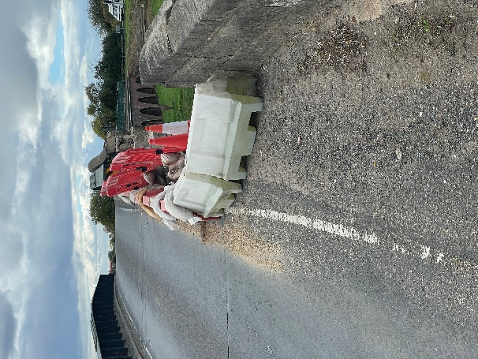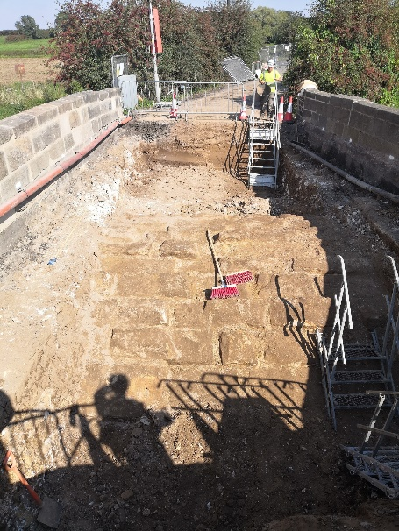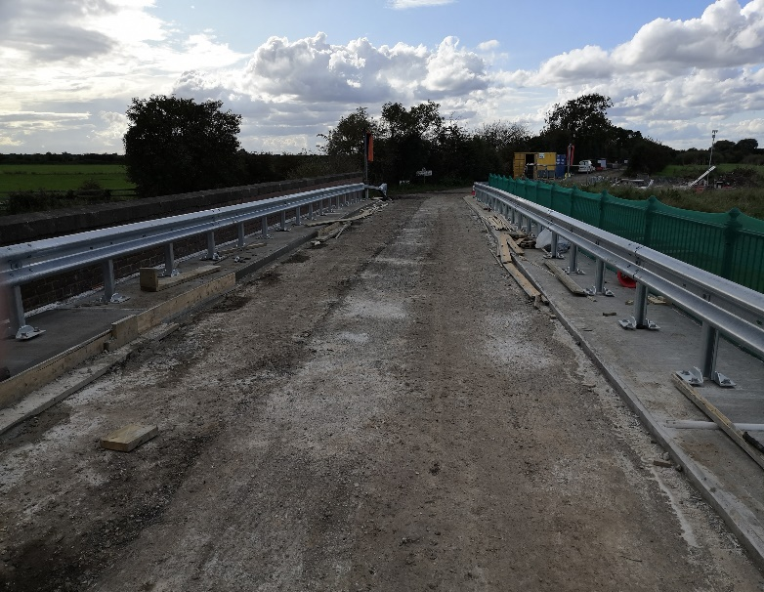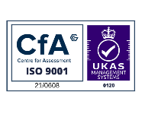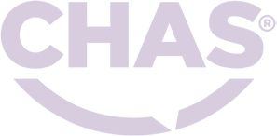

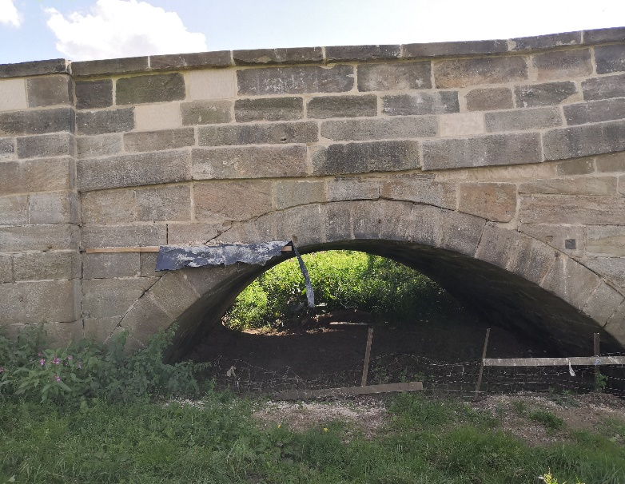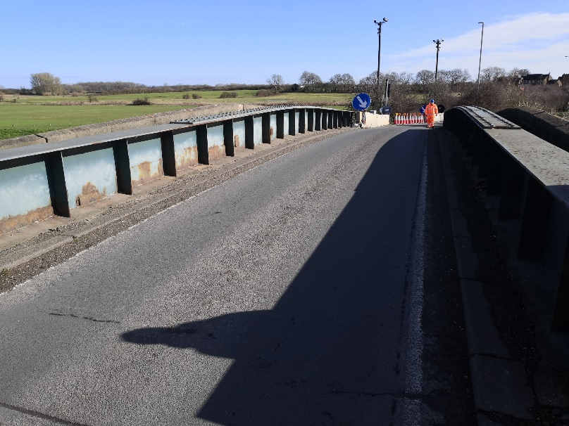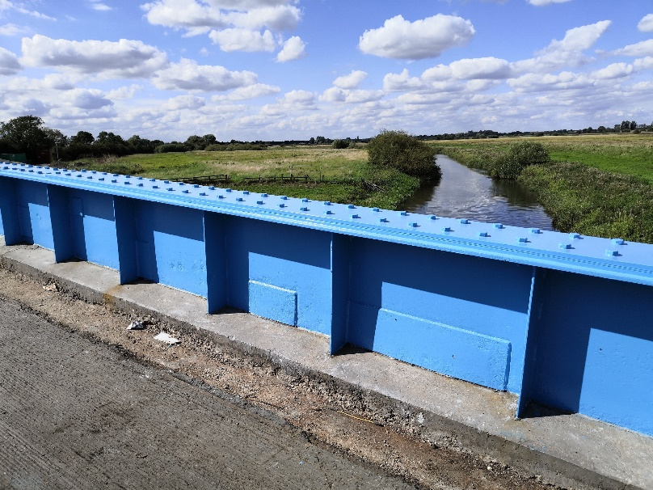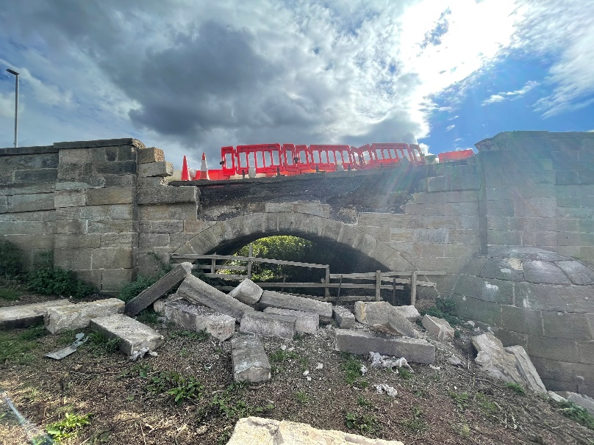

# A blue and white logo Description automatically generatedGraphical user interface, application Description automatically generatedLogo, company name Description automatically generatedLogo, company name Description automatically generated

# View more projects on our website: [www.masonclark.co.uk](https://www.masonclark.co.uk)

# Leeds Office: Unit E, Millshaw Business Living, Leeds, LS11 8PR

# York Office: Partnership House, Monks Cross Drive, York, YO32 9GZ

# 00

# Hull Office: Church House, 44 Newland Park, Kingston Upon Hull, HU5 2DW

# Leeds Office: Unit E, Millshaw Business Living, Leeds, LS11 8PR