Wigan Springs **Branch TMD**

Structural & Civil Engineering Design Services

**Client:**RTS Infrastructure Services

**Project Dates:**July 2023

**Project Value:**£100k

[View more details and images](https://www.masonclark.co.uk/projects/scarborough-west-pier-condition-surveys)

**Overview:**

Northern Trains Limited identified a need to improve security and operational efficiency at their Wigan Springs Traction Maintenance Depot (TMD).

To support this, a new security cabin was proposed at the entrance to the site.

The cabin would serve as a key control point for access and provide a dedicated space for staff to manage site activity.

The project was part of a broader effort to modernise depot infrastructure and ensure facilities meet current safety and operational standards.

RTS Infrastructure Services (RTS) instructed Mason Clark Associates (MCA) on behalf of Northern Trains Limited to undertake structural & civil engineering design services.

# Challenges and Solutions

# The project presented several logistical and technical challenges. The proposed cabin location was constrained by existing infrastructure, including buried services and limited working space. Additionally, the site’s ground conditions required careful assessment to ensure stable foundations.

# These issues were addressed by:

# Undertaking a detailed ground investigation, including trial pits and soil testing to inform foundation design.

# The design team developing a foundation solution that avoided underground utilities and accommodated the cabin’s structural needs.

# Coordinating with Network Rail and other stakeholders ensuring that all works complied with safety regulations and depot access requirements.

# Using a modular cabin to help streamline installation and reduce disruption to depot operations.



COMPANY LOGO

# MCA’s Contribution

# MCA led the civil and structural design for the project, working closely with mechanical and electrical consultants to ensure a fully coordinated solution.

# Our responsibilities included:

# Designing strip foundations tailored to the site’s ground conditions.

# Planning drainage connections and ensuring compliance with environmental standards.

# Supporting the integration of electrical and water services.

# Preparing detailed drawings, calculations, and risk assessments.

# Liaising with contractors and Network Rail to support safe and efficient delivery.

# Liaising with local authority to ensure the planning proposals followed permitted developments.

# Our collaborative approach helped ensure the project met all technical, safety, and operational requirements while minimising disruption to the depot.

# Results

The security cabin has been successfully installed and is now in use.

It provides a secure, functional space for staff to manage site access and monitor activity.

The cabin is equipped with power, lighting, heating, and water, and is fully integrated into the depot’s existing infrastructure.

Its location offers clear visibility of the access road, improving control over vehicle and personnel movements.

The project was delivered efficiently and in line with all relevant standards.

# A blue and white logo Description automatically generatedGraphical user interface, application Description automatically generatedLogo, company name Description automatically generatedLogo, company name Description automatically generated

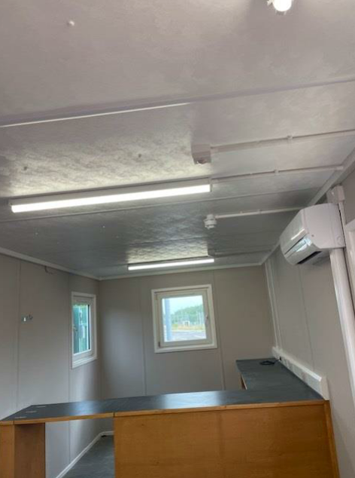

# View more projects on our website: [www.masonclark.co.uk](https://www.masonclark.co.uk)

# Leeds Office: Unit E, Millshaw Business Living, Leeds, LS11 8PR

# York Office: Partnership House, Monks Cross Drive, York, YO32 9GZ

# 00

# Hull Office: Church House, 44 Newland Park, Kingston Upon Hull, HU5 2DW

# Leeds Office: Unit E, Millshaw Business Living, Leeds, LS11 8PR